St. Christopher’s Episcopal Church
Eighteenth Sunday after Pentecost September 26, 2021, 10:15 am

You are very welcome to our Eucharist Service!
The entire service is printed below;
you’ll need no books or other materials to follow along.

The Priest or Leader will say the items in regular type.
You are invited to say aloud the items printed in boldface.

Prelude Prelude, A. Santelli

Announcements

All stand and join in singing,
Opening Hymn The Hymnal 1982 #359
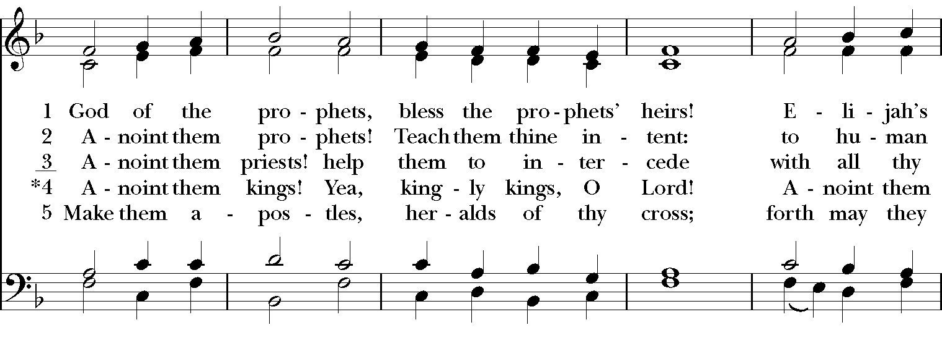
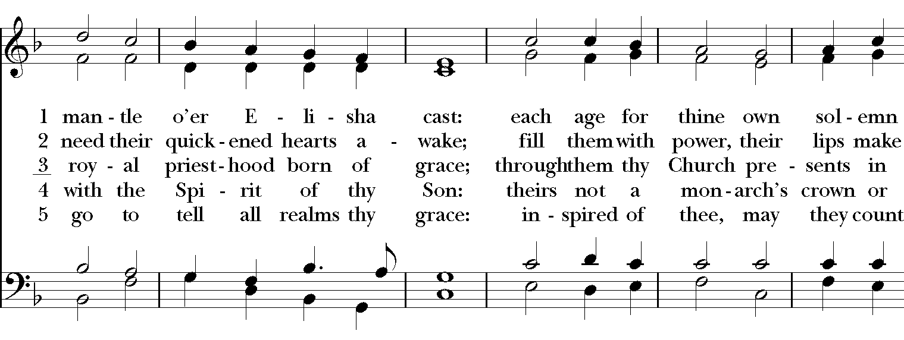
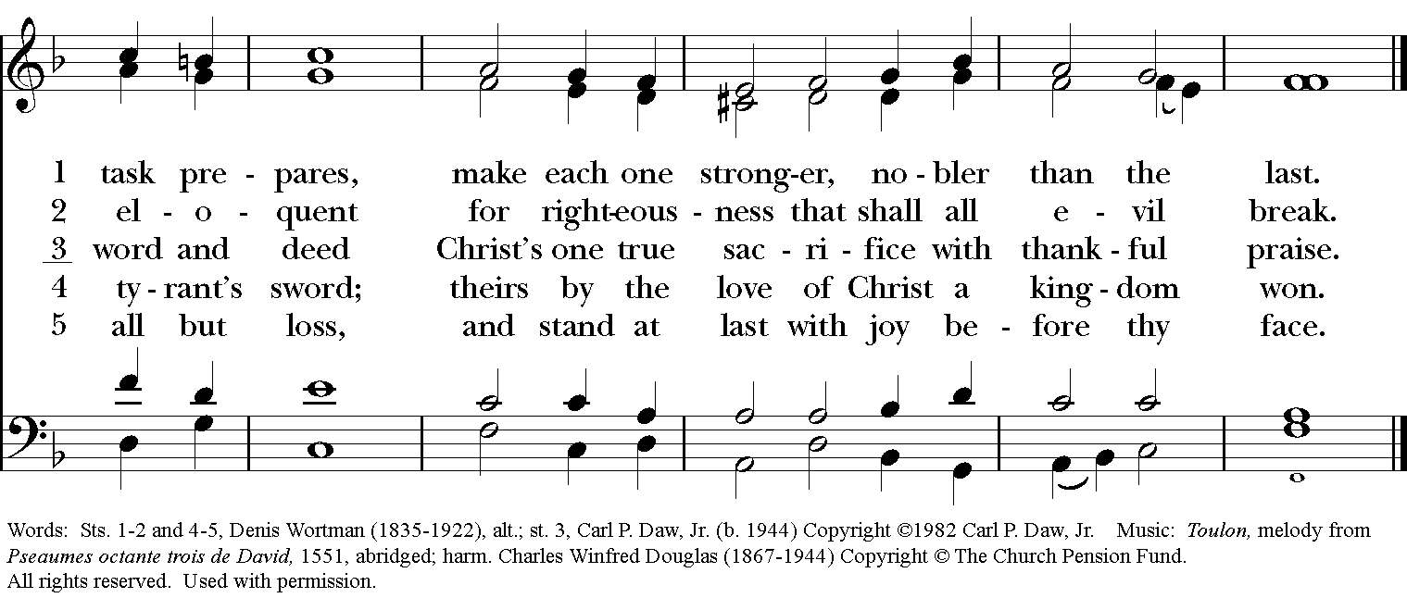
Permission to reprint, podcast, and/or stream the music in this service obtained from ONE LICENSE with license #723843-A. All rights reserved

The Opening Acclamation & Collect for Purity
Presider: Blessed be God: Father, Son, and Holy Spirit.
People: And blessed be his kingdom, now and for ever. Amen.
Presider: Almighty God, to you all hearts are open, all desires known, and from
you no secrets are hid: Cleanse the thoughts of our hearts by the inspiration of your Holy Spirit, that we may perfectly love you, and worthily magnify your holy Name; through Jesus Christ our Lord.
All: Amen.

A Song of Praise The Hymnal 1982 #S-236
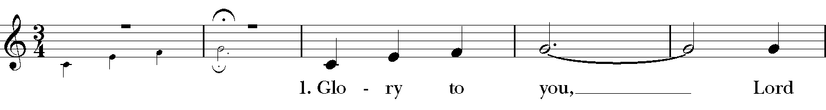
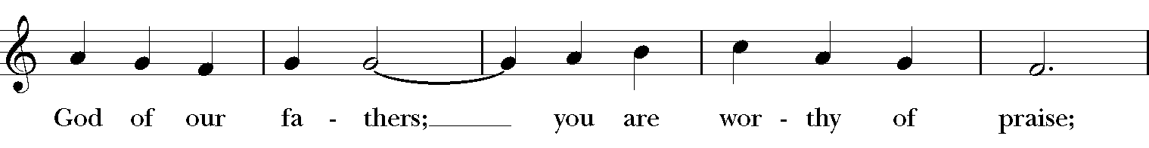
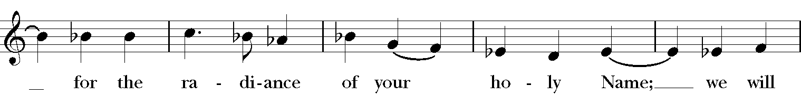
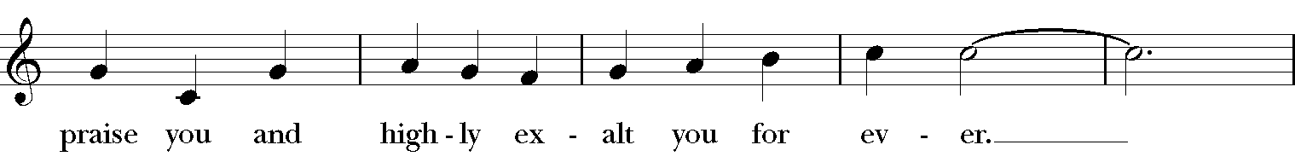
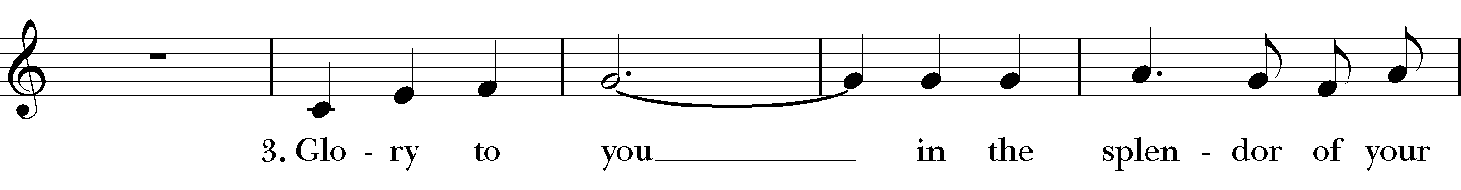
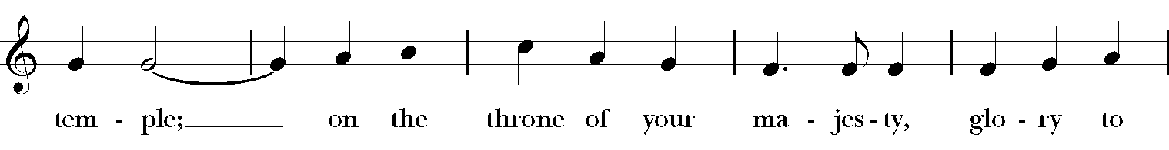
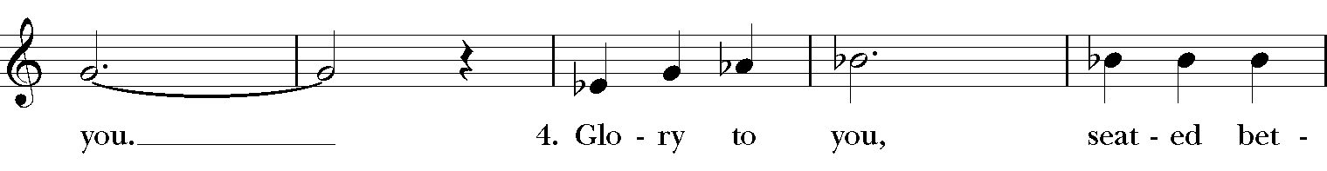
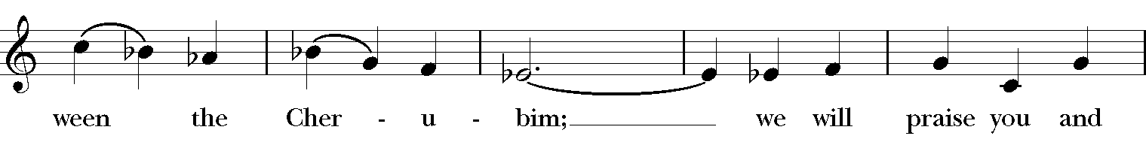
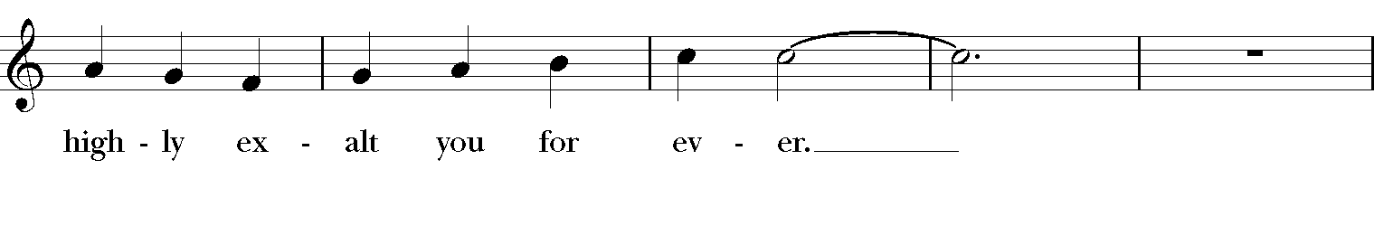
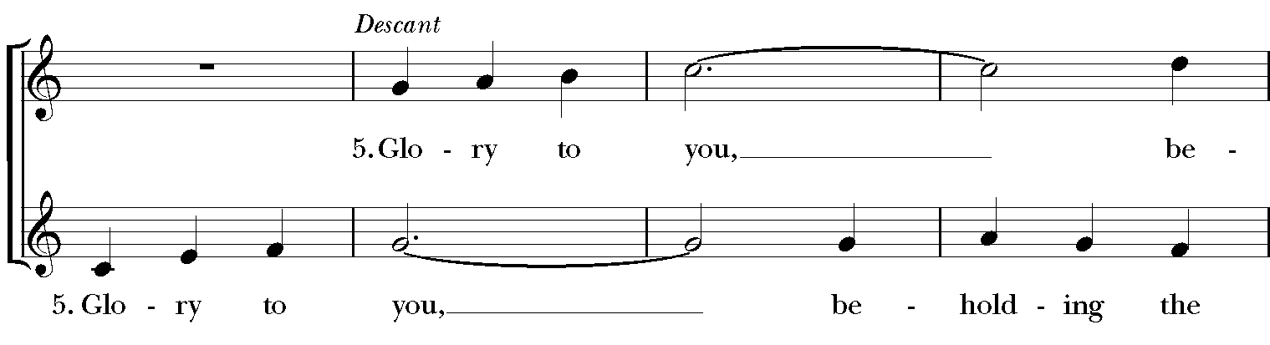
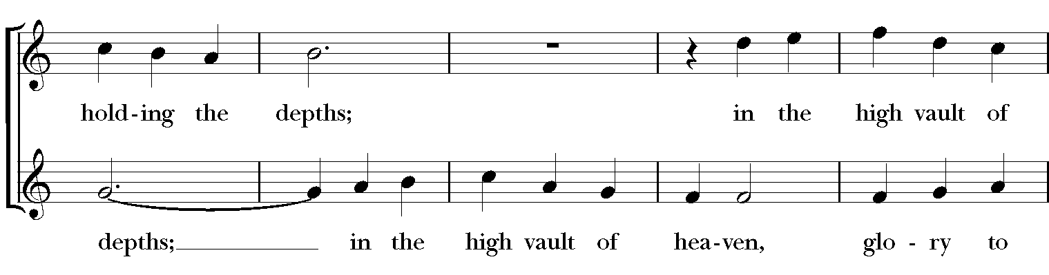
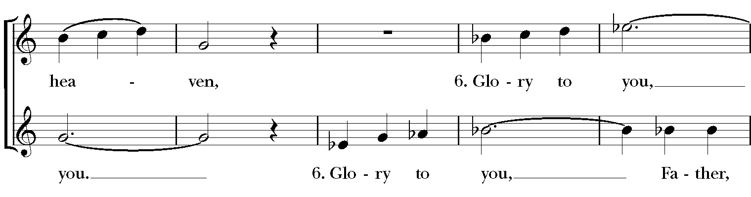
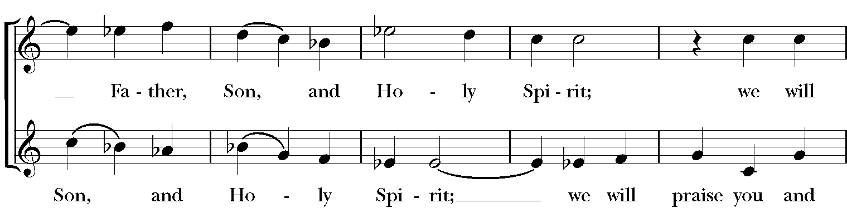
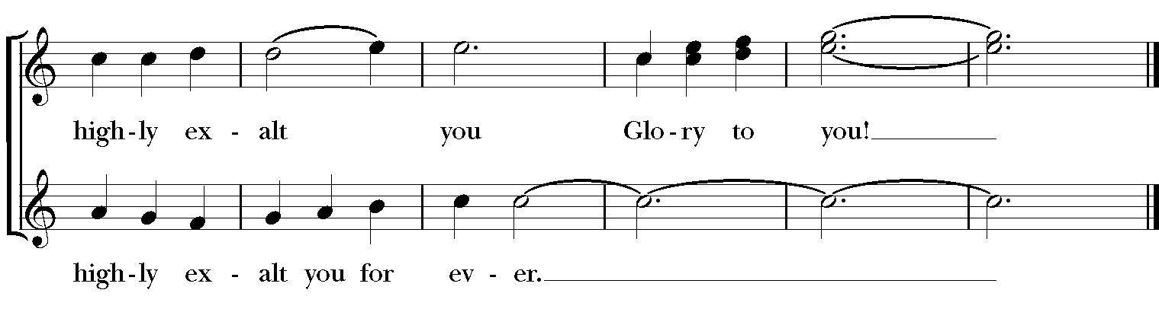

The Collect of the Day
Presider: The Lord be with you.
People: And also with you.
Presider: O God, you declare your almighty power chiefly in showing mercy and pity: Grant us the fullness of your grace, that we, running to obtain your promises, may become partakers of your heavenly treasure; through Jesus Christ our Lord, who lives and reigns with you and the Holy Spirit, one God, for ever and ever.
All: Amen.

The People are seated for the lessons.
The First Reading Numbers 11:4-6, 10-16, 24-29
A reading from the Book of Numbers.
The rabble among them had a strong craving; and the Israelites also wept again, and said, “If only we had meat to eat! We remember the fish we used to eat in Egypt for nothing, the cucumbers, the melons, the leeks, the onions, and the garlic; but now our strength is dried up, and there is nothing at all but this manna to look at.”

Moses heard the people weeping throughout their families, all at the entrances of their tents. Then the Lord became very angry, and Moses was displeased. So Moses said to the Lord, “Why have you treated your servant so badly? Why have I not found favor in your sight, that you lay the burden of all this people on me? Did I conceive all this people? Did I give birth to them, that you should say to me, ‘Carry them in your bosom, as a nurse carries a sucking child,’ to the land that you promised on oath to their ancestors? Where am I to get meat to give to all this people? For they come weeping to me and say, ‘Give us meat to eat!’ I am not able to carry all this people alone, for they are too heavy for me. If this is the way you are going to treat me, put me to death at once—if I have found favor in your sight—and do not let me see my misery.”

So the Lord said to Moses, “Gather for me seventy of the elders of Israel, whom you know to be the elders of the people and officers over them; bring them to the tent of meeting, and have them take their place there with you.

So Moses went out and told the people the words of the Lord; and he gathered seventy elders of the people, and placed them all around the tent. Then the Lord came down in the cloud and spoke to him, and took some of the spirit that was on him and put it on the seventy elders; and when the spirit rested upon them, they prophesied. But they did not do so again.

Two men remained in the camp, one named Eldad, and the other named Medad, and the spirit rested on them; they were among those registered, but they had not gone out to the tent, and so they prophesied in the camp. And a young man ran and told Moses, “Eldad and Medad are prophesying in the camp.” And Joshua son of Nun, the assistant of Moses, one of his chosen men, said, “My lord Moses, stop them!” But Moses said to him, “Are you jealous for my sake? Would that all the Lord’s people were prophets, and that the Lord would put his spirit on them!”

Reader: The Word of the Lord.
People: Thanks be to God.

The Psalm Psalm 19:7-14

7 The law of the Lord is perfect
and revives the soul; *
the testimony of the Lord is sure
and gives wisdom to the innocent.

8 The statutes of the Lord are just
and rejoice the heart; *
the commandment of the Lord is clear
and gives light to the eyes.

9 The fear of the Lord is clean
and endures for ever; *
the judgments of the Lord are true
and righteous altogether.

10 More to be desired are they than gold,
more than much fine gold, *
sweeter far than honey,
than honey in the comb.

11 By them also is your servant enlightened, *
and in keeping them there is great reward.

12 Who can tell how often he offends? *
cleanse me from my secret faults.

13 Above all, keep your servant from presumptuous sins;
let them not get dominion over me; *
then shall I be whole and sound,
and innocent of a great offense.

14 Let the words of my mouth and the meditation of my
heart be acceptable in your sight, *
O Lord, my strength and my redeemer.

The Second Reading James 5:13-20
A reading from the Letter of James.
Are any among you suffering? They should pray. Are any cheerful? They should sing songs of praise. Are any among you sick? They should call for the elders of the church and have them pray over them, anointing them with oil in the name of the Lord. The prayer of faith will save the sick, and the Lord will raise them up; and anyone who has committed sins will be forgiven. Therefore confess your sins to one another, and pray for one another, so that you may be healed. The prayer of the righteous is powerful and effective. Elijah was a human being like us, and he prayed fervently that it might not rain, and for three years and six months it did not rain on the earth. Then he prayed again, and the heaven gave rain and the earth yielded its harvest.

My brothers and sisters, if anyone among you wanders from the truth and is brought back by another, you should know that whoever brings back a sinner from wandering will save the sinner's soul from death and will cover a multitude of sins.

Reader: The Word of the Lord.
People: Thanks be to God.

Sequence Hymn The Hymnal 1982 #709
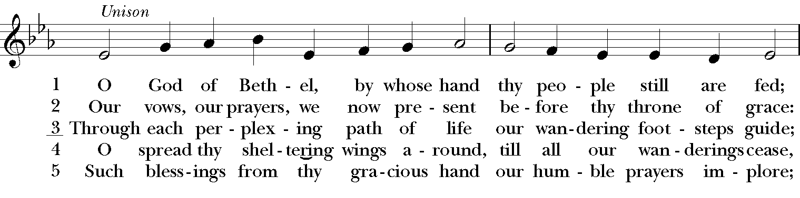
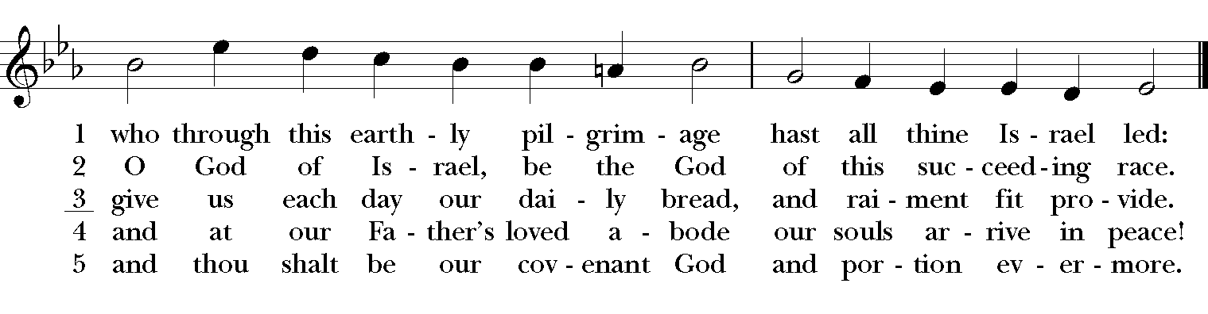
Permission to reprint, podcast, and/or stream the music in this service obtained from ONE LICENSE with license #723843-A. All rights reserved
The People stand as they are able for the Gospel,
The Gospel Mark 9:38-50
The Gospeler introduces the Gospel and the People respond,
People: Glory to you, Lord Christ.

John said to Jesus, “Teacher, we saw someone casting out demons in your name, and we tried to stop him, because he was not following us.” But Jesus said, “Do not stop him; for no one who does a deed of power in my name will be able soon afterward to speak evil of me. Whoever is not against us is for us. For truly I tell you, whoever gives you a cup of water to drink because you bear the name of Christ will by no means lose the reward.

“If any of you put a stumbling block before one of these little ones who believe in me, it would be better for you if a great millstone were hung around your neck and you were thrown into the sea. If your hand causes you to stumble, cut it off; it is better for you to enter life maimed than to have two hands and to go to hell, to the unquenchable fire. And if your foot causes you to stumble, cut it off; it is better for you to enter life lame than to have two feet and to be thrown into hell. And if your eye causes you to stumble, tear it out; it is better for you to enter the kingdom of God with one eye than to have two eyes and to be thrown into hell, where their worm never dies, and the fire is never quenched.

“For everyone will be salted with fire. Salt is good; but if salt has lost its saltiness, how can you season it? Have salt in yourselves, and be at peace with one another.”

Reader: The Gospel of the Lord.
People: Praise to you, Lord Christ.

At the invitation of the Preacher, the People are seated.
The Homily The Rev. Jerry Lasley

The Nicene Creed
All: We believe in one God,
the Father, the Almighty,
maker of heaven and earth,
of all that is, seen and unseen.

We believe in one Lord, Jesus Christ,
the only Son of God,
eternally begotten of the Father,
God from God, Light from Light,
true God from true God,
begotten, not made,
of one Being with the Father.
Through him all things were made.
For us and for our salvation
he came down from heaven:
by the power of the Holy Spirit
he became incarnate from the Virgin Mary,
and was made man.
For our sake he was crucified under Pontius Pilate;
he suffered death and was buried.
On the third day he rose again
in accordance with the Scriptures;
he ascended into heaven
and is seated at the right hand of the Father.
He will come again in glory to judge the living and the dead,
and his kingdom will have no end.

We believe in the Holy Spirit, the Lord, the giver of life,
who proceeds from the Father and the Son.
With the Father and the Son he is worshiped and glorified.
He has spoken through the Prophets.
We believe in one holy catholic and apostolic Church.
We acknowledge one baptism for the forgiveness of sins.
We look for the resurrection of the dead,
and the life of the world to come. Amen.

The Prayers of the People
The People stand as they are able during the prayers. The Leader and People pray responsively.

Leader: In peace, we pray to you, Lord God.
Silence
For all people in their daily life and work;
People: For our families, friends, and neighbors, and for those who are alone.

Leader: For this community, the nation, and the world;
People: For all who work for justice, freedom, and peace.

Leader: For the just and proper use of your creation;
People: For the victims of hunger, fear, injustice, and oppression.

Leader: For all who are in danger, sorrow, or any kind of trouble;
People: For those who minister to the sick, the friendless, and the needy.

Leader: For the peace and unity of the Church of God;
People: For all who proclaim the Gospel, and all who seek the Truth.

Leader: For Michael. our Presiding Bishop, and Skip our Assisting Bishop, for Jerry, our Priest; and for all bishops and other ministers;
People: For all who serve God in his Church.

Leader: For the special needs and concerns of this congregation, especially…
Silence. The People may add their own petitions either silently or aloud.
Leader: Hear us, Lord;
People: For your mercy is great.

Leader: We thank you, Lord, for all the blessings of this life.
Silence. The People may add their own thanksgivings either silently or aloud.
We will exalt you, O God our King;
People: And praise your Name for ever and ever.

Leader: We pray for all who have died, that they may have a place in your eternal
Kingdom.
Silence. The People may add their own petitions either silently or aloud.
Leader: Lord, let your loving-kindness be upon them;
People: Who put their trust in you.

The Priest adds a concluding Collect.
All: Amen.

All stand or kneel as they are able.
The Confession & Absolution
Priest: Let us confess our sins against God and our neighbor.
All: Most merciful God,
we confess that we have sinned against you
in thought, word, and deed,
by what we have done,
and by what we have left undone.
We have not loved you with our whole heart;
we have not loved our neighbors as ourselves.
We are truly sorry and we humbly repent.
For the sake of your Son Jesus Christ,
have mercy on us and forgive us;
that we may delight in your will,
and walk in your ways,
to the glory of your Name. Amen.
Priest: Almighty God have mercy on you, forgive you all your sins through our Lord Jesus Christ, strengthen you in all goodness, and by the power of the Holy Spirit keep you in eternal life.
All: Amen.

Priest: The Peace of the Lord be always with you.
All: And also with you.

Priest: Walk in love, as Christ loved us and gave himself for us, an offering and
sacrifice to God. Ephesians 5:2

Offertory Brother James’ Air, Jacob

The Holy Eucharist
All stand or kneel as they are able.
Priest: The Lord be with you.
People: And also with you.
Priest: Lift up your hearts.
People: We lift them to the Lord.
Priest: Let us give thanks to the Lord our God.
People: It is right to give him thanks and praise.
Priest: It is right, and a good and joyful thing, always and everywhere to give
thanks to you, Father Almighty, Creator of heaven and earth. Through Jesus Christ our Lord; who on the first day of the week overcame death and the grave, and by his glorious resurrection opened to us the way of everlasting life.

Therefore we praise you, joining our voices with Angels and Archangels and with all the company of heaven, who for ever sing this hymn to proclaim the glory of your Name:

Sanctus The hymnal 1982 #S-125
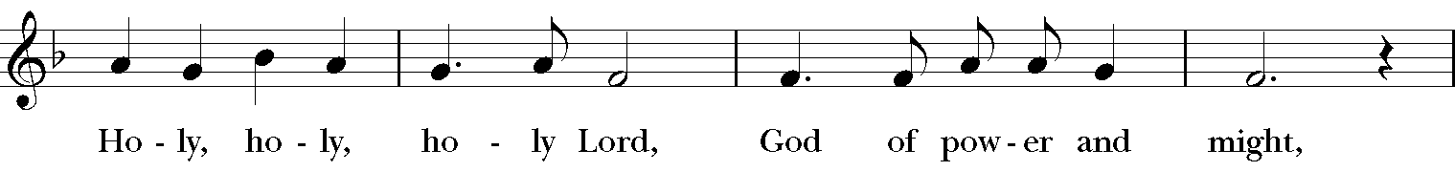
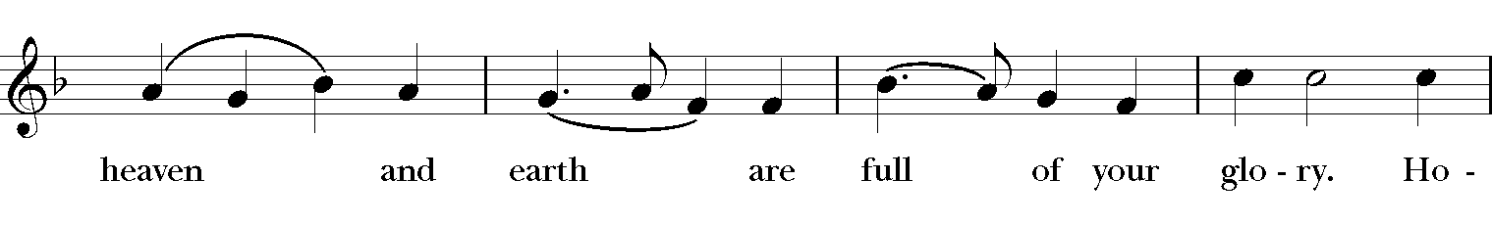
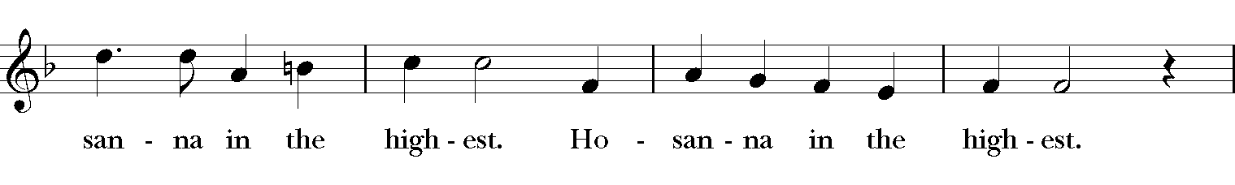
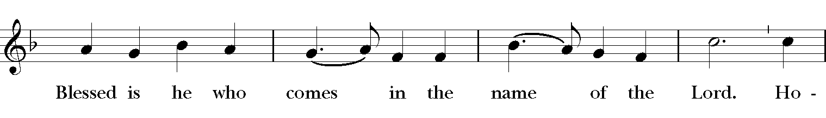
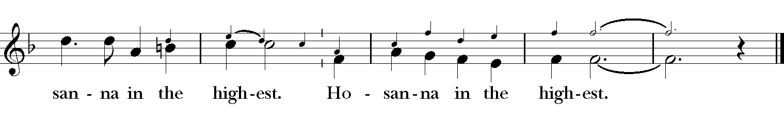

Priest: Holy and gracious Father: In your infinite love you made us for yourself, and,
when we had fallen into sin and become subject to evil and death, you, in your mercy, sent Jesus Christ, your only and eternal Son, to share our human nature, to live and die as one of us, to reconcile us to you, the God and Father of all.

He stretched out his arms upon the cross, and offered himself, in obedience to your will, a perfect sacrifice for the whole world.

At the following words concerning the bread, the Celebrant is to hold it, or to lay a hand upon it; and at the words concerning the cup, to hold or place a hand upon the cup and any other vessel containing wine to be consecrated.

Priest: On the night he was handed over to suffering and death, our Lord Jesus
Christ took bread; and when he had given thanks to you, he broke it, and gave it to his disciples, and said, “Take, eat: This is my Body, which is given for you. Do this for the remembrance of me.”

After supper he took the cup of wine; and when he had given thanks, he gave it to them, and said, “Drink this, all of you: This is my Blood of the new Covenant, which is shed for you and for many for the forgiveness of sins. Whenever you drink it, do this for the remembrance of me.”

Therefore we proclaim the mystery of faith:
All: Christ has died.
Christ is risen.
Christ will come again.

Priest: We celebrate the memorial of our redemption, O Father, in this sacrifice of
praise and thanksgiving. Recalling his death, resurrection, and ascension, we offer you these gifts.

Sanctify them by your Holy Spirit to be for your people the Body and Blood of your Son, the holy food and drink of new and unending life in him. Sanctify us also that we may faithfully receive this holy Sacrament, and serve you in unity, constancy, and peace; and at the last day bring us with all your saints into the joy of your eternal kingdom.

All this we ask through your Son Jesus Christ: By him, and with him, and in him, in the unity of the Holy Spirit all honor and glory is yours, Almighty Father, now and for ever.
All: Amen.

The Lord’s Prayer
Priest: As our Savior Christ has taught us, we are bold to say,
Our Father, who art in heaven,
hallowed be thy Name,
thy kingdom come, thy will be done,
on earth as it is in heaven.
Give us this day our daily bread.
And forgive us our trespasses,
as we forgive those who trespass against us.
And lead us not into temptation,
but deliver us from evil.
For thine is the kingdom,
and the power, and the glory,
for ever and ever. Amen.

The Breaking of the Bread
The Priest breaks the consecrated bread. A period of silence is kept.
Priest: Alleluia. Christ our Passover is sacrificed for us;
People: Therefore let us keep the feast. Alleluia.

Priest: The Gifts of God for the People of God.

All are invited to share in this sacred meal. This offering of the body and blood of our Savior Jesus Christ is for you, a precious child of God.

At this time, if you are joining us in-person, please carefully form a single line in the middle aisle beginning with the front rows and working back as space allows. Please make sure to stay at least six feet away from anyone not in your household and keep your mask on.

The Priest will distribute Communion wafers. Please keep your mask on as you approach then process to the left or right depending on where you are sitting. Please wait until you are far from the Priest and others before carefully removing your masks to partake of Communion. Please replace your mask as quickly as you are able.

All stand as they are able.
Post-Communion Prayer
Presider: Let us pray.
All: Eternal God, heavenly Father, you have graciously accepted us as living members of your Son our Savior Jesus Christ, and you have fed us with spiritual food in the Sacrament of his Body and Blood.
Send us now into the world in peace, and grant us strength and courage to love and serve you with gladness and singleness of heart;
through Christ our Lord. Amen.

The Blessing
The Presider blesses the People, and the People respond,
People: Amen.

Closing Hymn The hymnal 1982 #347
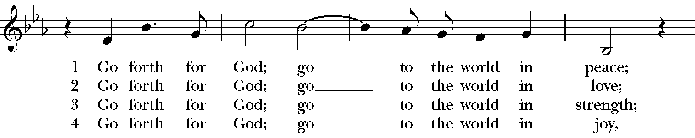
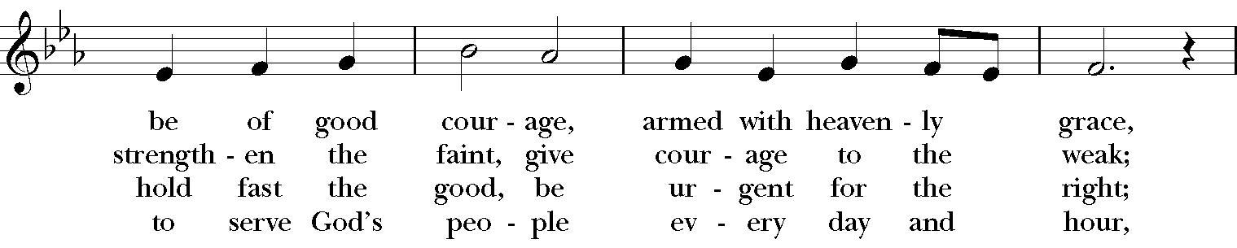
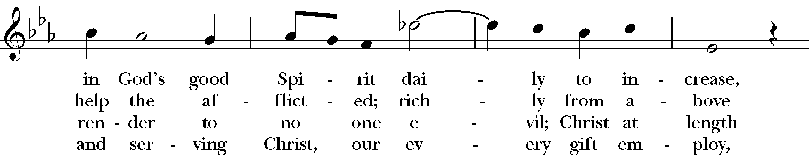
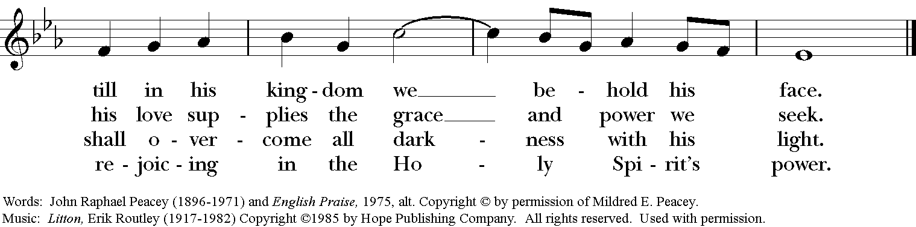
Permission to reprint, podcast, and/or stream the music in this service obtained from ONE LICENSE with license #723843-A. All rights reserved

The Dismissal
Presider: Go in peace to love and serve the Lord.
People: Thanks be to God.

Postlude Gothic March, G. Foschini

9020 South Saginaw Road, Grand Blanc, Michigan 48439
810.694.3600 | www.stchrisgrandblanc.org
Like us on Facebook: St. Christopher’s Episcopal Church
or www.facebook.com/stchrisgb

Sundays Holy Eucharist 8 am & 10:15 am

